**Short Essay MA1804 – Digital storytelling**

Students will write a 1,500-word essay from a set list designed by the course lecturers relating to the first 4 ‘blocks’ of teaching. Questions will ask students to consider a particular aspect of digital media in relation to theories, ideas and conventions of narrative and storytelling.

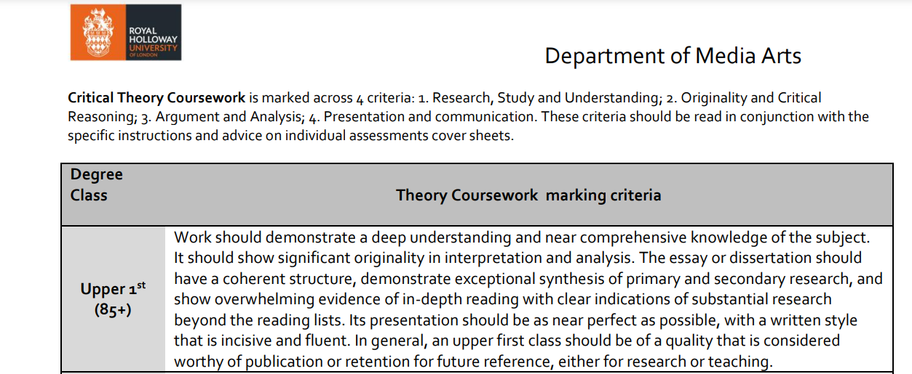

1. **How can you express an opinion that the seminar screening text ‘Joan Is Awful’?**

Joan is awful is a Black Mirror episode which I remember watching when it first came out, the themes of the episode surround social media and the amount that is put out there. The information that is stored about you online is always thought about as being owned by the user, however the episode dives into the topic of the information about you being not only being accessed by you, but also used. The story surrounds a woman Joan who eventually realises that her entire life is recorded and streamed on a service which ironically can be compared to as “Netflix” the streaming service you would be using already to watch black mirror.

Social Media has since I first installed it in 2011, been integrated into our lives, and is used to show the world who we are and what we do, however it has gotten to a point where people are able to pretend to be someone or something that they are not, also known as “Catfishing.” Mark Zuckerberg the CEO of Facebook, described social media as being “The Avatar of the self,” and when you forge a new self, you can be seen as having “A lack of integrity.”

Joan is seen as awful because she has her life unfiltered and documented for everything, for her self which cannot be forged, but the question surrounds,

does that make her awful? The unhappiest social media pages are normally run by the happiest people, they feel no need to pretend to be someone they are not, because they are happy with who they are.

1. **To what extent does Social Media Impact mental and physical health through the digital stories we tell?**

I would personally argue that Social Media can impact mental and physical health through the digital stories we tell to a vast extent, media and stories are something that can be blurred together as there is no one to filter out all of the “Fake News,” out there.

Among the most noticeable negative impacts is the social comparison issues. Users' self-esteem is lowered and false expectations are fostered by the continual exposure to idealised images of other people's lives. A widespread fear of missing out (FOMO) is fueled by the carefully chosen highlights and scripted tales, which leaves people feeling inadequate and unhappy.

Essentially, users may experience negative consequences from the delicately constructed digital stories on social media. It's crucial to understand the dangers of social comparison, cyberbullying, and the need for approval in order to encourage more thoughtful and responsible social media use. Promoting a healthy online environment requires consumers to recognise the potential harm of manufactured stories as they navigate Social-Media.

1. **How is it possible that such an outlandish ‘internet story’ as QAnon can grip a collective of people so vehemently to the point where they are actively involved in real world acts of violence?**

Personally, I believe that stories are mostly well received by the young and those who are impressionable. In this case it being the right wing and those down that pipeline leading to conspiracy theory. I believe it being due to the idea of “Post Truth,” and the appealing to feelings and belief rather than to reason, Groups and rallies can be gathered through stories and can also be weaponized into doing whatever the person who made the story wants.

The QAnon narrative, based on false claims of a deep state conspiracy against President Trump, gained traction against a backdrop of political conflict and cultural upheaval. The post-truth period, characterized by a disregard for objective reality and the exaggeration of subjective opinions, offered an ideal environment for such conspiracy theories to flourish.

A willingness to fight and group against an invisible foe created out of thin air is usually created and catalyzed by Social Media, with the use of Deepfake imagery and overall editing, stories can be created easily to the point where the entire internet you need to be skeptical of what you read.

Taking care of the root causes of the post-truth age is crucial as society struggles with the fallout from conspiracy theories such as QAnon. To lessen the influence of such false narratives on public discourse and, eventually, on actual acts, it is imperative that critical thinking, media literacy, and responsible information distribution receive increased attention, but who to trust?

1. **Interactive narrative forms of storytelling offer the consumer agency in their consumption of the narrative’. To what extent could this be either a progressive or regressive form of storytelling when compared to traditional media forms where no agency is involved?**

I would say the extent to which this interactivity is either progressive or regressive depends on various factors, including the depth of engagement, the narrative's structure, and the intended impact on the audience.

Unlike traditional media, which mostly favours passive consumption, interactive narrative forms of storytelling offer a subtle improvement since they allow the consumer to actively shape the story.

On the progressive side, interactive storytelling offers an opportunity for change by empowering users to influence the plot, characters, and outcomes. With this newfound agency, people can create original narratives that speak to their viewpoints and create a feeling of immersion and intimate connection. This evolution is best shown by interactive CD Roms, video games, and virtual reality experiences where people become active participants and increase their emotional engagement and overall satisfaction. An example of this would be Dungeons and Dragons, which is a narrative where almost everything is your own choice, or is chosen by your friend who decided on the campaign…

The origin of these narrative forms came from “choose your own adventure books,” where it forced the reader to render the image themselves. But back then potential for regression came about when the experience is disjointed or fragmented. If there is a lack of balance between agency and narrative coherence then usually the thematic impact that was intended is lost.

In conclusion I believe that when implemented thoughtfully, the interactivity of narratives can be progressive, engaging and a lot of fun, but they do need to be done right in order for them to be as good, if not better than traditional media forms where no agency is involved.

1. **What are the ethical issues that arise when considering Citizen Journalism?​**

I would argue that the use of social media especially can be argued as being ethical, if that media was posted by the person themselves and are okay with posting the data in the first place. There are some issues to do with privacy as some data may be found without you realising you are putting it out there. However, you could argue that it is just due to human carelessness.

In the modern era of social media, where information spreads quickly and increases the impact of both accurate and false reporting, citizen journalism has additional ethical issues. The fast nature of social media platforms such as Facebook, Instagram, and Twitter might encourage a culture that values speed above accuracy. This could lead citizen journalists to place more value on sharing an event firsthand than on verifying that it is true. This pressure makes it more likely that inaccurate or unconfirmed information will be spread, which could lead to panic attacks or propaganda spirals.

But sometimes Citizen Journalism has a positive impact on the world, from OSINT that helps solve crimes against children to the FBI being able to track dangerous people down from reverse image search and complex tools using open-source techniques. They use old photos to decipher location from even the tiniest bit of data.

Members of 4chan from my experience browsing the site, were able to track missing people down, decipher century old mysteries and much more from using Citizen Journalism, in some senses it can be impressive to see with what people can find out just from their chair.